**The**[**German Empire**](https://www.britannica.com/place/German-Empire)**, 1871–1918**

The German Empire was founded on January 18, 1871, in the aftermath of three successful wars by the North German state of Prussia. Within a seven-year period [Denmark](https://www.britannica.com/place/Denmark), the Habsburg monarchy, and [France](https://www.britannica.com/place/France) were vanquished in short, decisive conflicts. The empire was forged not as the result of the outpouring of nationalist feeling from the masses but through traditional cabinet diplomacy and agreement by the leaders of the states in the North German Confederation, led by [Prussia](https://www.britannica.com/place/Prussia), with the hereditary rulers of [Bavaria](https://www.britannica.com/place/Bavaria), [Baden](https://www.britannica.com/place/Baden-historical-state-Germany), [Hesse-Darmstadt](https://www.britannica.com/place/Hesse-Darmstadt), and [Württemberg](https://www.britannica.com/place/Wurttemberg). Prussia, occupying more than three-fifths of the area of Germany and having approximately three-fifths of the [population](https://www.britannica.com/science/population-biology-and-anthropology), remained the dominant force in the nation until the empire’s demise at the end of another war in 1918.

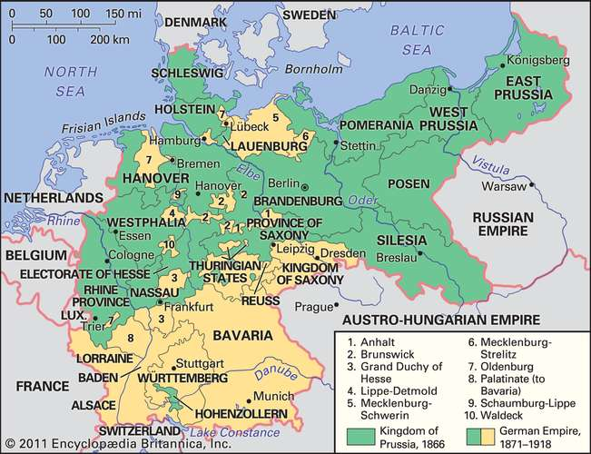

The German Empire, 1871–1918. *Encyclopedia Britannica, Inc.*